NAME : Biancaa.R

2210329

DATE : 7.2.2023

EX:8:PYTHON PROGRAMMING USING TUPLES

AIM:

To execute programs in python using Tuples.

1. **Write a python program to display the number in words [Tuple].**

Eg. 123 O/p: ("one", "two”, “three”)

def words(num):

tup=() dict={"0":"Zero","1":"One","2":"Two","3":"Three","4":"Four","5":"Five","6":"Six",

"7":"Seven","8":"Eight","9":"Nine"} for i in num:

tup+=(dict[i],) return tup

num=input("Enter the number:") print(words(num))



1. **Consider a tuple as T = (1, 3, 2, 4, 6, 5). Write a program to store numbers present at odd index into a new tuple.**

T=(1,3,2,4,6,5)

tup=()

for i in range(1,len(T),2): tup+=(T[i],)

print("New tuple:",tup)



3. Consider the mark_list=[('Rams',120,55,45,65,45,32),

('Vel',121,94,86,78,67,90), ('Siri',122,73,98,90,87,89)]

which contains the name, register number and marks of corresponding student as list of tuples. Create a new tuple that assigns a grade based on the following conditions:

if Marks >=90 then grade A

if Marks >=80 && <90 then grade B if Marks >65 && < 80 then grade C

if Marks > =40 && <=65 then grade D Output:

[('Rams',120,Grades),( )]

mark_list=[('Rams',120,55,45,65,45,32), ('Vel',121,94,86,78,67,90), ('Siri',122,73,98,90,87,89)]

new_list=[]

for i in mark_list:

tup=() index=0

for mark in i:

if index==0 or index==1:

tup+=(mark,) elif mark>=90:

tup+=("A",)

elif mark>=80 and mark<90: tup+=("B",)

elif mark>65 and mark<80: tup+=("C",)

elif mark>=40 and mark<=65: tup+=("D",)

else:

tup+=("F",)

index+=1 new_list+=[tup]

print(new_list) for i in new_list:

print(i)

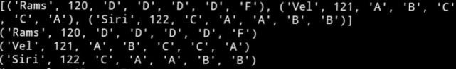

1. **Write a Python program to create a list of tuples having first element as the number and second element as the cube of the number.**

list1=eval(input("Enter the list:")) list2=[]

for i in list1:

tup=() tup+=(i,i**3) list2.append(tup)

print("Cube list",list2)



1. **Given list of tuples, remove all the tuples with length K. Input : test_list = [(4, 5), (4, ), (8, 6, 7), (1, ), (3, 4, 6, 7)], K = 2 Output : [(4, ), (8, 6, 7), (1, ), (3, 4, 6, 7)]**

Input : test_list = [(4, 5), (4, ), (8, 6, 7), (1, ), (3, 4, 6, 7)], K = 3

Output : [(4, 5), (4, ), (1, ), (3, 4, 6, 7)]

test_list=eval(input("Enter the list of tuples:")) K=int(input("Enter the length:"))

List=[]

for tup in test_list:

length=len(tup) if length==K:

continue

else:

print(List)

List.append(tup)

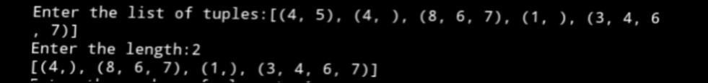

1. **Given a list, find frequency of each element and save it as list of tuple [(number, frequency)].**

Input : test_list = [4, 5, 4, 5, 6, 6, 5]

Output : [(4, 2), (5, 3), (6, 2)]

Input : test_list = [4, 5, 4, 5, 6, 6, 6]

Output : [(4, 2), (5, 3), (6, 3)]

test_list=eval(input("Enter the list:")) Set=set(test_list)

List=[]

for number in Set:

Tup=() frequency=test_list.count(number) Tup+=(number,frequency) List.append(Tup)

print("List",List)



1. **Write a python program to remove duplicates from tuple.**

tup=eval(input("Enter the tuple:")) new_tup=()

for i in tup:

if i not in new_tup:

new_tup+=(i,) print("Without duplicates:",new_tup)



1. **Given a list of tuples, extract all tuples having K digit elements.**

Input: test_list = [(54, 2), (34, 55), (222, 23), (12, 45), (78, )], K = 2

Output: [(34, 55), (12, 45), (78,)]

Explanation: All tuples have numbers with 2 digits.

Input: test_list = [(54, 2), (34, 55), (222, 23), (12, 45), (782, )], K = 3

Output: [(782,)]

**Explanation: All tuples have numbers with 3 digits.** test_list=eval(input("Enter the list of tuples:")) K=int(input("Enter the digit:"))

List=[Tup for Tup in test_list if all(len(str(num))==K for num in Tup) ] print(List)





LEARNING OUTCOME:

By completing this assignment I have learnt to execute programs in python using Tuples.